**TABLES**

Table 1

*Item Types, Contents, Domains, ITCc, GGUM and 2PL Parameters of Personality Items in the Order Scale*

|  |  |  |  |  |  |  |  |  |  |  |
| --- | --- | --- | --- | --- | --- | --- | --- | --- | --- | --- |
|  |  |  |  |  | **GGUM** | | |  | **2PL** | |
| **Item** | **Type** | **Contents** | **Domain** | **ITCc** | ***α*** | ***δ*** | ***τ*** |  | ***a*** | ***b*** |
| 1 | Positive | I wish that everyone was as organized as me. |  | .57 | 1.52 | 1.62 | -1.64 |  | 0.91 | -0.05 |
| 2 | Positive | Organizing and arranging things is extremely fulfilling. |  | .51 | 1.22 | 1.71 | -2.67 |  | 0.79 | -0.96 |
| 3 | Positive | I plan my time very carefully. |  | .57 | 1.21 | 1.89 | -2.06 |  | 0.88 | -0.21 |
| 4 | Positive | I follow a strict daily schedule. |  | .48 | 0.92 | 1.46 | -1.01 |  | 0.63 | 0.27 |
| 5 | Negative | Organizing things is a waste of time. |  | .51 | 1.67 | -3.11 | -0.79 |  | 0.99 | -2.28 |
| 6 | Negative | I prefer not to plan ahead and instead take life as it comes. |  | .42 | 1.13 | -1.71 | -0.47 |  | 0.62 | -1.22 |
| 7 | Negative | I am an unorganized person. |  | .61 | 2.15 | -1.99 | -0.94 |  | 1.23 | -1.02 |
| 8 | Negative | It's hard for me to keep things in order. |  | .57 | 2.33 | -1.83 | -0.82 |  | 1.21 | -1.01 |
| 9 | Intermediate | I try to keep track of my bills, but I'm not too accurate | Transition | -.26 | 1.03 | -1.22 | -0.29 |  | 0.12 | 4.13 |
| 10 | Intermediate | I try to keep my room clean and tidy, but I don't always have time to do so. | Transition | -.11 | 1.99 | -0.32 | -1.68 |  | 0.27 | -3.08 |
| 11 | Intermediate | I can ignore a mess for a long time, but eventually I clean it up. | Transition | -.47 | 1.68 | -1.28 | -1.64 |  | 0.09 | -2.71 |
| 12 | Intermediate | Occasionally I miss a deadline or two. | Frequency | -.33 | 1.02 | -1.37 | -0.76 |  | 0.10 | 2.63 |
| 13 | Intermediate | Sometimes I do not put things in their proper place. | Frequency | -.54 | 2.14 | -0.96 | -1.96 |  | 0.12 | -6.16 |
| 14 | Intermediate | Sometimes I can tolerate the messiness of my room. | Frequency | -.44 | 1.68 | -0.81 | -1.90 |  | 0.14 | -5.18 |
| 15 | Intermediate | I spend time cleaning and organizing things when I am not busy. | Condition | .58 | 1.15 | 1.69 | -2.29 |  | 0.80 | -0.60 |
| 16 | Intermediate | I deviate from my routines when needed. | Condition | -.08 | 1.06 | -0.39 | -3.15 |  | 0.26 | -5.53 |
| 17 | Intermediate | When my desk gets too messy, I will clean it up. | Condition | .45 | 2.06 | 0.69 | -2.47 |  | 1.11 | -1.72 |
| 18 | Intermediate | I am about average in regard to details. | Average | -.14 | 0.69 | -0.65 | -0.74 |  | 0.17 | -0.14 |
| 19 | Intermediate | My room neatness is about average. | Average | .01 | 1.93 | -0.05 | -1.23 |  | 0.35 | -1.39 |
| 20 | Intermediate | I consider myself as organized as most other people. | Average | .21 | 1.24 | 0.27 | -1.26 |  | 0.48 | -0.88 |

*Note.* *N* = 355. ITCc = Corrected item-total correlation.

Table 2

*Item Types, Contents, Domains, ITCc, GGUM and 2PL Parameters of Personality Items in the Dominance Scale*

|  |  |  |  |  |  |  |  |  |  |  |
| --- | --- | --- | --- | --- | --- | --- | --- | --- | --- | --- |
|  |  |  |  |  | **GGUM** | | |  | **2PL** | |
| **Item** | **Type** | **Contents** | **Domain** | **ITCc** | ***α*** | ***δ*** | ***τ*** |  | ***a*** | ***b*** |
| 1 | Positive | I enjoy being in a position of power. |  | .74 | 2.55 | 1.61 | -2.34 |  | 1.50 | -0.71 |
| 2 | Positive | I can give orders when I am in a leadership position. |  | .59 | 1.53 | 0.66 | -2.89 |  | 0.86 | -2.22 |
| 3 | Positive | I enjoy leading a group. |  | .78 | 3.26 | 1.45 | -2.40 |  | 2.11 | -0.89 |
| 4 | Positive | I want to take charge of everything I do. |  | .40 | 0.73 | 1.94 | -1.43 |  | 0.43 | 0.24 |
| 5 | Negative | I am not a leader. |  | .75 | 3.14 | -2.56 | -1.23 |  | 1.99 | -1.26 |
| 6 | Negative | I dislike taking the responsibility of leading a group. |  | .71 | 2.48 | -2.25 | -1.32 |  | 1.90 | -0.82 |
| 7 | Negative | I try to avoid leadership roles. |  | .80 | 3.98 | -2.37 | -1.49 |  | 2.96 | -0.80 |
| 8 | Negative | Given a choice of being a follower or a leader, I would always choose to be a follower. |  | .73 | 3.34 | -2.43 | -1.44 |  | 2.07 | -0.92 |
| 9 | Intermediate | I am usually not vocal about my opinions, but I will speak up when needed. | Transition | -.32 | 0.97 | -1.53 | -2.13 |  | 0.11 | -3.19 |
| 10 | Intermediate | I am a forceful person, but I also feel comfortable making compromises. | Transition | .39 | 0.73 | 1.47 | -1.83 |  | 0.43 | -0.60 |
| 11 | Intermediate | I like to be a leader, but I also enjoy being a follower. | Transition | .11 | 1.52 | -0.23 | -1.90 |  | 0.35 | -2.69 |
| 12 | Intermediate | Sometimes I can persuade my friends to do things in my way. | Frequency | .28 | 0.83 | 1.12 | -4.10 |  | 0.50 | -3.02 |
| 13 | Intermediate | Sometimes I feel comfortable leading a group. | Frequency | .58 | 1.65 | 0.87 | -2.65 |  | 1.01 | -1.72 |
| 14 | Intermediate | Occasionally I speak up to influence others' decisions. | Frequency | .41 | 1.14 | 0.66 | -3.17 |  | 0.65 | -2.56 |
| 15 | Intermediate | I will lead a group only when I'm interested in getting the task done. | Condition | -.27 | 0.93 | -1.42 | -1.72 |  | 0.11 | -1.77 |
| 16 | Intermediate | I do not mind taking the leadership position if nobody else in the group would like to. | Condition | .65 | 1.83 | 1.37 | -3.03 |  | 1.22 | -1.56 |
| 17 | Intermediate | I will take charge only when I feel it is necessary. | Condition | -.41 | 1.43 | -1.82 | -2.06 |  | ## | ## |
| 18 | Intermediate | Compared to my friends, I am about average in showing dominance over others. | Average | .13 | 1.16 | -0.03 | -1.28 |  | 0.34 | -1.31 |
| 19 | Intermediate | I am as dominant as other people on average. | Average | .17 | 1.08 | 0.05 | -1.15 |  | 0.35 | -0.92 |
| 20 | Intermediate | My desire to lead a group is about average. | Average | -.01 | 1.47 | -0.37 | -1.26 |  | 0.23 | -1.66 |

*Note.* *N* = 355. ITCc = Corrected item-total correlation. ## = Item parameters cannot be estimated by BILOG program.

Table 3

*Item Types, Contents, Domains, ITCc, GGUM and 2PL Parameters of Personality Items in the Curiosity Scale*

|  |  |  |  |  |  |  |  |  |  |  |
| --- | --- | --- | --- | --- | --- | --- | --- | --- | --- | --- |
|  |  |  |  |  | **GGUM** | | |  | **2PL** | |
| **Item** | **Type** | **Contents** | **Domain** | **ITCc** | ***α*** | ***δ*** | ***τ*** |  | ***a*** | ***b*** |
| 1 | Positive | I am excited about new knowledge. |  | .67 | 2.32 | 0.95 | -2.64 |  | 1.43 | -1.61 |
| 2 | Positive | I am fascinated by science. |  | .37 | 0.73 | 1.42 | -2.20 |  | 0.58 | -0.84 |
| 3 | Positive | I like to learn new things whenever I have time. |  | .57 | 1.31 | 1.02 | -2.50 |  | 1.07 | -1.31 |
| 4 | Positive | I am always intrigued by what I learn in classes. |  | .36 | 0.81 | 1.20 | -1.05 |  | 0.69 | -0.03 |
| 5 | Negative | I am not curious about the things that I don’t know. |  | .40 | 1.08 | -2.69 | -0.57 |  | 0.73 | -1.89 |
| 6 | Negative | I learn new things only when I have to. |  | .48 | 1.83 | -2.70 | -1.38 |  | 0.82 | -1.49 |
| 7 | Negative | I am not interested in learning new things. |  | .45 | 1.17 | -3.27 | -0.61 |  | 0.64 | -2.75 |
| 8 | Negative | I would prefer a job where I don't have to learn anything new. |  | .50 | 1.88 | -2.77 | -1.33 |  | 0.98 | -1.50 |
| 9 | Intermediate | I can be persuaded to try some new things, but most of the time I am reluctant to do so. | Transition | -.30 | 0.86 | -1.81 | -0.76 |  | 0.14 | 2.92 |
| 10 | Intermediate | I like to experience new things, but seldom have time. | Transition | .02 | 0.65 | -0.74 | -1.15 |  | 0.24 | -0.76 |
| 11 | Intermediate | I am not excited about new technology, but I become interested when others show me how to use it. | Transition | -.20 | 0.75 | -1.63 | -0.84 |  | 0.15 | 1.52 |
| 12 | Intermediate | Sometimes I read non-fiction books to learn something new. | Frequency | .38 | 0.65 | 1.86 | -1.03 |  | 0.48 | 0.42 |
| 13 | Intermediate | At times I prefer to try new things rather than stick to old choices. | Frequency | .26 | 0.85 | 1.09 | -2.59 |  | 0.46 | -1.79 |
| 14 | Intermediate | Occasionally I find myself interested in information that I really don't need. | Frequency | .32 | 1.06 | 0.95 | -3.14 |  | 0.65 | -2.23 |
| 15 | Intermediate | I am open to new concepts only if they are not hard to understand. | Condition | -.42 | 1.69 | -1.79 | -1.41 |  | 0.09 | 2.65 |
| 16 | Intermediate | I try new restaurants only when other people recommend them. | Condition | -.17 | 0.77 | -1.74 | -0.77 |  | 0.16 | 1.99 |
| 17 | Intermediate | I do not mind trying new things when there are not many choices. | Condition | .10 | 0.97 | -0.18 | -3.03 |  | 0.32 | -4.28 |
| 18 | Intermediate | I am about as curious as my friends. | Average | -.07 | 0.79 | -0.29 | -2.16 |  | 0.24 | -2.99 |
| 19 | Intermediate | I am about average in curiosity about new knowledge. | Average | -.35 | 1.05 | -1.26 | -1.61 |  | 0.12 | -1.93 |
| 20 | Intermediate | I have a moderate interest in learning new skills. | Average | .11 | 0.86 | -0.52 | -2.79 |  | 0.28 | -3.76 |

*Note.* *N* = 355. ITCc = Corrected item-total correlation.

|  |  |  |  |  |  |  |  |  |  |  |
| --- | --- | --- | --- | --- | --- | --- | --- | --- | --- | --- |
|  |  |  |  |  | **GGUM** | | |  | **2PL** | |
| **Item** | **Type** | **Contents** | **Domain** | **ITCc** | ***α*** | ***δ*** | ***τ*** |  | ***a*** | ***b*** |
| 1 | Positive | I enjoy things like laying brick or tile very much. |  | .68 | 1.81 | 2.56 | -0.81 |  | 1.18 | 1.63 |
| 2 | Positive | I like to work on an offshore oil-drilling rig more than most people. |  | .42 | 1.44 | 3.17 | -0.84 |  | 0.95 | 2.14 |
| 3 | Positive | I have a passion on setting up and operating machines to make products. |  | .62 | 2.14 | 2.00 | -0.50 |  | 1.33 | 1.47 |
| 4 | Positive | I am always willing to repair household appliances. |  | .66 | 2.31 | 1.97 | -1.30 |  | 1.46 | 0.66 |
| 5 | Positive | I always feel excited about fixing things around the house. |  | .58 | 1.70 | 1.69 | -1.22 |  | 1.04 | 0.44 |
| 6 | Intermediate | I like fixing a broken faucet only when nobody else can. | Condition | .55 | 1.17 | 1.82 | -0.65 |  | 0.73 | 1.06 |
| 7 | Intermediate | Sometimes I like to fix mechanical things for fun. | Frequency | .77 | 3.01 | 2.25 | -1.52 |  | 1.90 | 0.73 |
| 8 | Intermediate | My interest in installing flooring in houses is about average. | Average | .54 | 1.62 | 1.52 | -0.83 |  | 0.86 | 0.72 |
| 9 | Intermediate | I would like to operate a machine on a production line, but I would soon get bored. | Transition | .49 | 1.17 | 1.93 | -0.92 |  | 0.76 | 0.87 |
| 10 | Intermediate | I have a moderate interest in repairing and installing locks. | Average | .68 | 1.97 | 2.06 | -0.73 |  | 1.27 | 1.26 |
| 11 | Negative | I don't think it interesting to operate a grinding machine in a factory. |  | .40 | 1.07 | -0.69 | -2.25 |  | 0.59 | 1.64 |
| 12 | Negative | I don't like building kitchen cabinets. |  | .64 | 2.39 | -0.84 | -1.55 |  | 1.25 | 0.69 |
| 13 | Negative | I have no interest in building a brick walkway. |  | .67 | 2.17 | -0.91 | -2.03 |  | 1.26 | 1.11 |

Table 4

*Item Types, Contents, Domains, ITCc, GGUM and 2PL Parameters of Vocational Interest Items in the Realistic Scale*

*Note.* *N* = 355. ITCc = Corrected item-total correlation.

Table 5

*Item Types, Contents, Domains, ITCc, GGUM and 2PL Parameters of Vocational Interest Items in the Social Scale*

|  |  |  |  |  |  |  |  |  |  |  |
| --- | --- | --- | --- | --- | --- | --- | --- | --- | --- | --- |
|  |  |  |  |  | **GGUM** | | |  | **2PL** | |
| **Item** | **Type** | **Contents** | **Domain** | **ITCc** | ***α*** | ***δ*** | ***τ*** |  | ***a*** | ***b*** |
| 1 | Positive | I love giving career advice to people. |  | .23 | 0.58 | 1.15 | -1.18 |  | 0.36 | -0.32 |
| 2 | Positive | I always enjoy helping elderly people with their daily activities. |  | .43 | 1.33 | 0.90 | -1.16 |  | 0.65 | -0.27 |
| 3 | Positive | I am more interested in teaching an elementary school class than most other people. |  | .57 | 1.14 | 1.63 | -1.34 |  | 0.79 | 0.16 |
| 4 | Positive | I would always love to work with mentally disabled children. |  | .65 | 3.12 | 1.00 | -1.04 |  | 1.53 | 0.03 |
| 5 | Positive | I would love to have the opportunity to teach disabled people work and living skills. |  | .67 | 3.48 | 1.03 | -1.24 |  | 1.95 | -0.16 |
| 6 | Intermediate | I would help people with family-related problems only if I was paid. | Condition | -.13 | 0.45 | -2.99 | -0.53 |  | 0.15 | 3.42 |
| 7 | Intermediate | Sometimes I like to teach children how to read. | Frequency | .61 | 1.56 | 1.63 | -2.38 |  | 0.98 | -0.74 |
| 8 | Intermediate | I like to help my neighbors only when I have time. | Condition | -.04 | 0.60 | -0.71 | -1.04 |  | 0.15 | -0.98 |
| 9 | Intermediate | My interest in taking care of children is about average. | Average | .00 | 0.62 | -0.21 | -1.26 |  | 0.18 | -1.60 |
| 10 | Intermediate | Although I like to volunteer in charities, I am usually not motivated. | Transition | -.35 | 1.30 | -1.09 | -0.50 |  | ## | ## |
| 11 | Negative | I don't find teaching a high-school class attractive to me. |  | .33 | 0.60 | -1.09 | -0.84 |  | 0.34 | 0.01 |
| 12 | Negative | I have no interest in helping people with drug or alcohol problems. |  | .30 | 1.01 | -1.81 | -0.44 |  | 0.51 | -1.41 |
| 13 | Negative | I don't like supervising the activities of children at a camp. |  | .55 | 1.48 | -2.05 | -0.91 |  | 0.93 | -1.04 |

*Note.* *N* = 355. ITCc = Corrected item-total correlation. ## = Item parameters cannot be estimated by BILOG program.

Table 6

*Item Types, Contents, Domains, ITCc, GGUM and 2PL Parameters of Vocational Interest Items in the Artistic Scale*

|  |  |  |  |  |  |  |  |  |  |  |
| --- | --- | --- | --- | --- | --- | --- | --- | --- | --- | --- |
|  |  |  |  |  | **GGUM** | | |  | **2PL** | |
| **Item** | **Type** | **Contents** | **Domain** | **ITCc** | ***α*** | ***δ*** | ***τ*** |  | ***a*** | ***b*** |
| 1 | Positive | I love drawing pictures. |  | .69 | 2.70 | 1.95 | -1.69 |  | 1.62 | 0.20 |
| 2 | Intermediate | I like to draw pictures only when I have time. | Condition | .58 | 1.97 | 1.07 | -1.00 |  | 0.90 | 0.06 |
| 3 | Negative | I have no interest in drawing. |  | .68 | 2.64 | -1.77 | -1.75 |  | 1.60 | -0.04 |
| 4 | Positive | I always have a strong interest in playing a musical instrument. |  | .36 | 0.81 | 0.82 | -0.94 |  | 0.28 | -1.38 |
| 5 | Intermediate | Sometimes I like to play a musical instrument. | Frequency | .50 | 1.01 | 0.88 | -1.58 |  | 0.65 | -0.06 |
| 6 | Negative | I don't think playing musical instruments is interesting. |  | .39 | 0.86 | -2.80 | -0.95 |  | 0.48 | -2.21 |
| 7 | Positive | I always dream of acting in a play. |  | .46 | 0.97 | 1.96 | -0.35 |  | 0.67 | 1.43 |
| 8 | Intermediate | I have a moderate interest in acting compared to people on average. | Average | .46 | 0.73 | 2.26 | -1.09 |  | 0.52 | 0.75 |
| 9 | Negative | I don't like acting at all. |  | .46 | 0.88 | -1.95 | -1.53 |  | 0.61 | -0.33 |
| 10 | Positive | I love taking Art courses. |  | .75 | 3.65 | 1.98 | -1.54 |  | 2.38 | 0.43 |
| 11 | Intermediate | I have a moderate interest in taking Art courses. | Average | .68 | 2.56 | 1.30 | -1.27 |  | 1.53 | 0.00 |
| 12 | Negative | I don't find Art courses are interesting. |  | .73 | 2.40 | -1.95 | -1.76 |  | 1.60 | -0.22 |
| 13 | Positive | I have a passion on designing artwork. |  | .70 | 2.31 | 2.27 | -1.24 |  | 0.94 | 0.92 |
| 14 | Intermediate | I like designing artwork only when I have time. | Condition | .63 | 3.18 | 1.02 | -0.75 |  | 1.28 | 0.36 |
| 15 | Negative | I have no interest in designing artwork. |  | .73 | 3.23 | -1.38 | -1.62 |  | 1.84 | 0.24 |

*Note.* *N* = 355. ITCc = Corrected item-total correlation.

Table 7

*Item Types, Contents, Domains, ITCc, GGUM and 2PL Parameters of Vocational Interest Items in the Investigative Scale*

|  |  |  |  |  |  |  |  |  |  |  |
| --- | --- | --- | --- | --- | --- | --- | --- | --- | --- | --- |
|  |  |  |  |  | **GGUM** | | |  | **2PL** | |
| **Item** | **Type** | **Contents** | **Domain** | **ITCc** | ***α*** | ***δ*** | ***τ*** |  | ***a*** | ***b*** |
| 1 | Positive | I have a strong interest in reading science-related articles |  | .80 | 2.52 | 1.89 | -1.47 |  | 1.63 | 0.40 |
| 2 | Intermediate | My interest in reading scientific articles is about average. | Average | .30 | 1.31 | 0.51 | -1.19 |  | 0.46 | -0.65 |
| 3 | Negative | I don't find it interesting to read science-related articles. |  | .68 | 2.28 | -1.79 | -1.28 |  | 1.47 | -0.44 |
| 4 | Positive | I always feel excited about conducting research in a lab. |  | .64 | 1.27 | 2.09 | -1.60 |  | 0.82 | 0.39 |
| 5 | Intermediate | l like to working in a lab only if it is not time consuming. | Condition | .36 | 1.10 | 0.62 | -0.23 |  | 0.39 | 1.01 |
| 6 | Negative | I have no interest in doing research in a lab. |  | .64 | 1.62 | -1.96 | -1.33 |  | 1.06 | -0.53 |
| 7 | Positive | I think it is very fascinating to study scientific theories. |  | .79 | 2.84 | 1.88 | -1.79 |  | 1.83 | 0.11 |
| 8 | Intermediate | Sometimes I like to study scientific theories, but not always. | Frequency | .51 | 2.50 | 0.59 | -1.10 |  | 0.80 | -0.35 |
| 9 | Negative | I hate studying a scientific theory. |  | .67 | 2.62 | -1.63 | -1.22 |  | 1.63 | -0.37 |
| 10 | Positive | I am very interested in science-related courses. |  | .80 | 3.37 | 1.55 | -1.62 |  | 2.17 | -0.04 |
| 11 | Intermediate | From time to time I find science-related courses are interesting. | Frequency | .67 | 1.99 | 1.41 | -2.64 |  | 1.26 | -1.16 |
| 12 | Negative | I think courses on science are boring. |  | .78 | 3.21 | -2.10 | -1.57 |  | 2.11 | -0.48 |
| 13 | Positive | I would love to have the opportunity to work on a scientific project. |  | .82 | 3.73 | 1.78 | -1.83 |  | 2.51 | -0.02 |
| 14 | Intermediate | I have a moderate interest in working on scientific projects. | Average | .76 | 2.32 | 1.70 | -1.96 |  | 1.49 | -0.23 |
| 15 | Negative | I dislike working on any scientific project. |  | .70 | 2.60 | -1.58 | -0.99 |  | 1.50 | -0.57 |

*Note.* *N* = 355. ITCc = Corrected item-total correlation.

Table 8

*Means and Standard Deviations of the Adjusted χ2/df Ratios of GGUM and 2PL Models for Each Scale*

|  |  |  |  |  |  |  |  |
| --- | --- | --- | --- | --- | --- | --- | --- |
| **Scale** | **Number of Items** | **GGUM Mean Adjusted *χ*2/*df*** | | | **2PL Mean Adjusted *χ*2/*df*** | | |
| **Singlets** | **Doublets** | **Triplets** | **Singlets** | **Doublets** | **Triplets** |
| **Personality Scales** | | | | | | | |
| Order | 20 | 0.00 | 1.33 | 1.68 | 0.00 | 19.92 | 27.86 |
| (0.00) | (5.45) | (4.24) | (0.00) | (32.77) | (31.33) |
| Dominance | 20 | 0.00 | 1.28 | 1.41 | 0.00 | 7.13 | 9.15 |
| (0.00) | (5.17) | (3.78) | (0.00) | (18.23) | (14.38) |
| Curiosity | 20 | 0.00 | 1.07 | 1.22 | 0.00 | 10.22 | 12.83 |
| (0.00) | (3.84) | (3.26) | (0.00) | (21.79) | (18.65) |
| **Vocational Interest Scales** | | | | | | | |
| Artistic | 15 | 0.00 | 10.02 | 13.34 | 32.38 | 33.97 | 31.14 |
| (0.00) | (40.75) | (31.50) | (71.32) | (62.20) | (44.05) |
| Investigative | 15 | 0.04 | 2.12 | 2.16 | 0.00 | 1.34 | 3.04 |
| (0.15) | (6.64) | (4.73) | (0.00) | (5.63) | (6.21) |
| Realistic | 13 | 0.00 | 1.04 | 1.05 | 0.00 | 0.74 | 0.96 |
| (0.00) | (4.32) | (2.84) | (0.00) | (3.33) | (2.78) |
| Social | 13 | 0.00 | 2.29 | 3.12 | 0.00 | 5.36 | 6.91 |
| (0.00) | (8.07) | (6.92) | (0.00) | (10.15) | (7.91) |

*Note.* Values in the parentheses denote the standard deviations.

Table 9

*Means and Standard Deviations of the Adjusted χ2/df Ratios of GGUM and 2PL Models for Personality Scales by Intermediate Domains*

|  |  |  |  |  |
| --- | --- | --- | --- | --- |
| **Scale** | **Number**  **of Items** | **GGUM Mean Adjusted *χ*2/*df*** | | |
| **Singlets** | **Doublets** | **Triplets** |
| **Order** | | | | |
| Transition | 11 | 0.00 | 1.33 | 1.60 |
| (0.00) | (5.37) | (3.84) |
| Frequency | 11 | 0.00 | 0.81 | 0.98 |
| (0.00) | (3.14) | (2.35) |
| Condition | 11 | 0.00 | 1.03 | 1.35 |
| (0.00) | (4.38) | (3.59) |
| Average | 11 | 0.00 | 0.81 | 0.88 |
| (0.00) | (3.91) | (2.64) |
| **Dominance** | | | | |
| Transition | 11 | 0.00 | 0.71 | 1.06 |
| (0.00) | (3.24) | (2.55) |
| Frequency | 11 | 0.00 | 1.22 | 1.47 |
| (0.00) | (3.79) | (3.36) |
| Condition | 11 | 0.00 | 0.78 | 0.83 |
| (0.00) | (3.41) | (2.40) |
| Average | 11 | 0.00 | 1.56 | 1.72 |
| (0.00) | (6.47) | (4.11) |
| **Curiosity** | | | | |
| Transition | 11 | 0.00 | 0.38 | 0.35 |
| (0.00) | (1.58) | (1.17) |
| Frequency | 11 | 0.00 | 0.52 | 0.33 |
| (0.00) | (2.32) | (1.27) |
| Condition | 11 | 0.00 | 0.44 | 0.38 |
| (0.00) | (2.28) | (1.43) |
| Average | 11 | 0.00 | 0.46 | 0.24 |
| (0.00) | (2.11) | (1.32) |

*Note.* Values in the parentheses denote the standard deviations.

**FIGURES**

*Figure 1.* Example of an item response function (IRF) based on the dominance model.

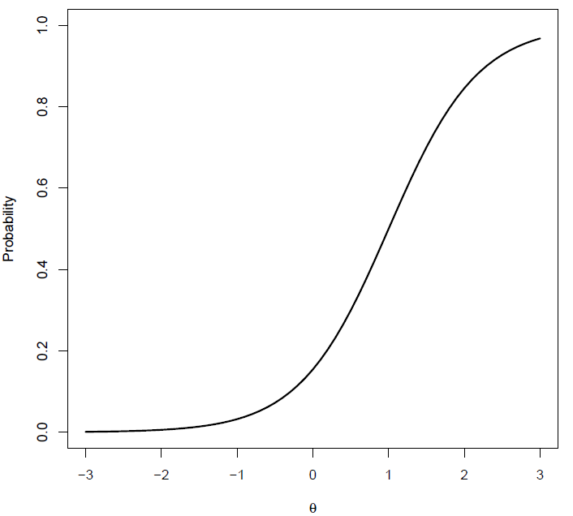

*Figure 2.* Example of an item response function (IRF) based on the ideal point model.

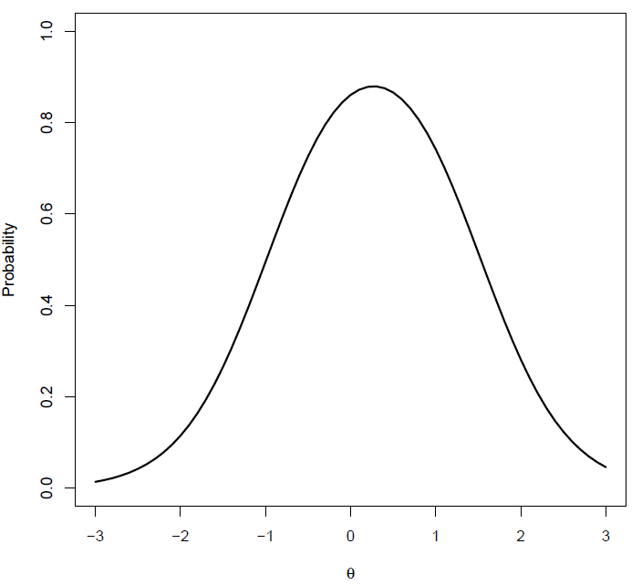

*Figure 3a.* 2PL Fit plots for Item 3 of the Order scale generated by MODFIT 3.0 (Stark, 2001). IRF stands for the item response function predicted by the model, and EMP stands for the empirical response function. The error bars represent the 95% confidence intervals for the empirical points.

*Figure 3b.* GGUM Fit plots for Item 3 of the Order scale by MODFIT 3.0 (Stark, 2001). ORF stands for the option response function of option 1 predicted by the model, and EMP stands for the empirical response function. The error bars represent the 95% confidence intervals for the empirical points.

*Figure 4a.* 2PL Fit plots for Item 10 of the Order scale by MODFIT 3.0 (Stark, 2001). IRF stands for the item response function predicted by the model, and EMP stands for the empirical response function. The error bars represent the 95% confidence intervals for the empirical points.

*Figure 4b.* GGUM Fit plots for Item 10 of the Order scale by MODFIT 3.0 (Stark, 2001). ORF stands for the option response function of option 1 predicted by the model, and EMP stands for the empirical response function. The error bars represent the 95% confidence intervals for the empirical points.

*Figure 5.* Comparison of item information functions for Item 3 in the Order scale between the GGUM and the 2PL model.

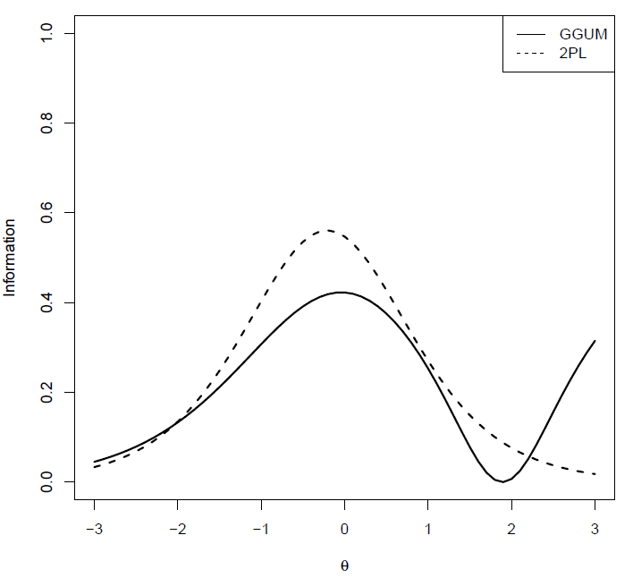

*Figure 6.* Comparison of item information functions for Item 10 in the Order scale between the GGUM and the 2PL model.

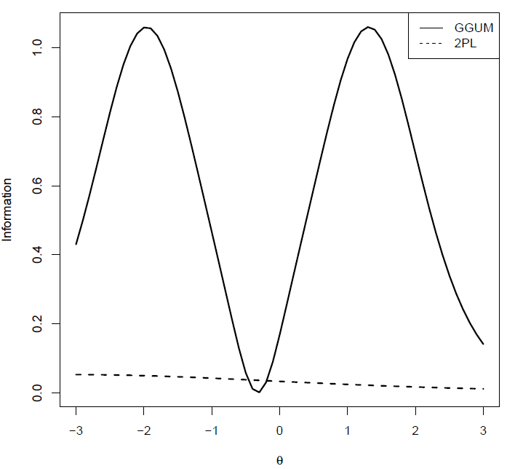

*Figure 7a.* Comparison of test information functions for the Order scale between the GGUM and the 2PL model.

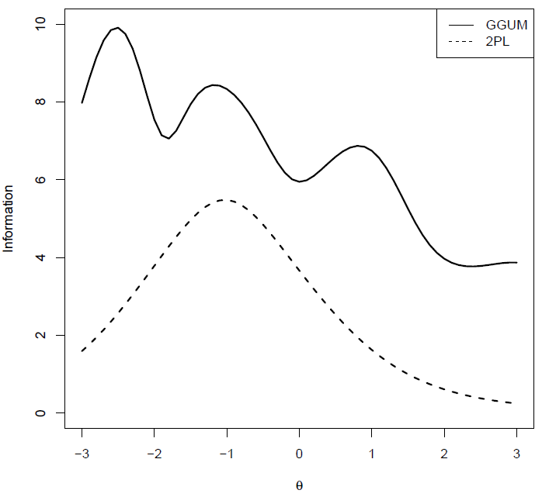

*Figure 7b.* Comparison of test information functions for the Dominance scale between the GGUM and the 2PL model.

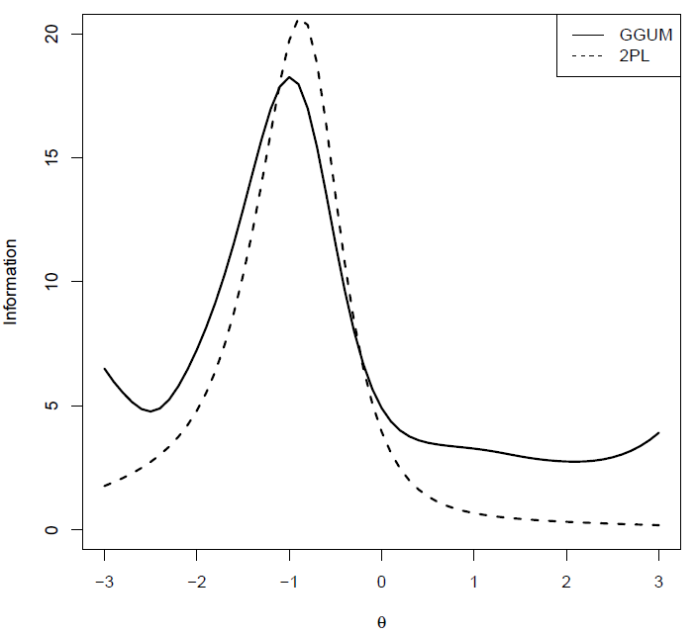

*Figure 7c.* Comparison of test information functions for the Curiosity scale between the GGUM and the 2PL model.

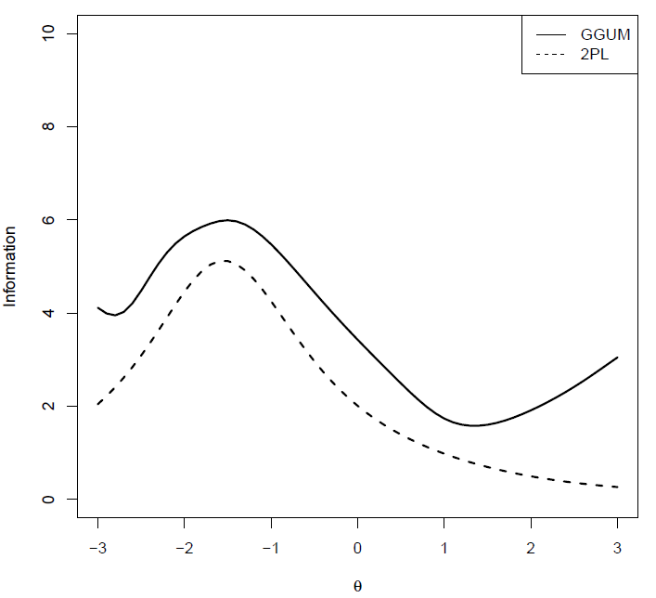

*Figure 8.* Comparison of cumulated information functions between all extreme items and all intermediate items in the Dominance scale based on the GGUM.

